FineQuo-

---------------------------------------------------------------------------------

A contradistinctive approach put forth by the 4 Co-founders- Tathya Shah, Garv Sawhney, Ishaan Meena, Priyansh Mathur- of FineQuo to positively amend the status quo and promote a healthier lifestyle: -

The Winchester School

Dubai

Jabel Ali

* The purpose 3
* The Problem 4
* How, What and Why 6
* UAE’s Agenda 7
* The Making and Production 8
* Visual Representation 11
* ****Business Model 12

-------------------------------------------------------------------

Millions of people follow an unhealthy lifestyle. Hence, they encounter illness, disability and even death. ... Malnutrition, unhealthy diet, smoking, alcohol consuming, drug abuse, stress and so on, are the presentations of unhealthy life style that they are used as dominant form of lifestyle. We have put forth this contradistinctive approach to solve this chronic issue, our product will most certainly provide a significant boost towards this positive change.

To further understand this problem and why we have initiated this movement to help amend it for the good of us all, lets put the spotlight on a few statistics. Poor nutrition can impair our daily health and wellbeing and reduce our ability to lead an enjoyable and active life.

Now that we have that out of the way, let’s consider what we are dealing with…The United Nations Food and Agriculture Organization (FAO) estimates that about 815 million people of the 7.6 billion people in the world, or 10.7%, were suffering from chronic unhealthiness in 2016. Almost all the unhealthy people live in lower-middle-income countries.

Our contradistinctive approach to this chronic issue is a simple, effortless piece of technology- The FineQuo App- Co-founded by Garv, Tathya, Ishaan and Priyansh. FineQuo is an app that encourages users to follow a healthier lifestyle to further cement the prevention of unhealthy

1

Living by simply amending the lifestyles that are followed currently by encouraging the users to complete simple daily tasks.

In 2015, when the United Nations Sustainable Development Goals were officially adopted, the clock began ticking on an ambitious goal: ending unhealthiness by 2030. At the time, that target seemed achievable; during the previous 15 years, the number of unhealthy people on the planet had been reduced by half, a staggering achievement attributed largely to new era technology. Nowadays, surrounded by ample amounts of technology, we can use this so-called metaphoric “bullet” to our advantage. To pierce through the core of unhealthiness and prevent this world issue.

In the short term, poor nutrition can contribute to stress, tiredness and our capacity to work, and over time, it can contribute to the risk of developing some illnesses and other health problems like: -

* Obesity
* High Cholesterol
* Heart Diseases and Prone to Strokes
* Diabetes
* Osteoporosis

Hence why, our product will most certainly help the user curve this chronic issue and promote healthy living for the betterment of everyone.

2

***The Purpose: -***

We strive to promote and instill a sense of what good can healthy lifestyles can bring to the table. We believe that we are all the same, we are all humans. Even though we compose different traits and different lifestyles, we all belong to the same community. Hence why, we put forth this contradistinctive idea to promote and encourage humans to follow a healthy lifestyle which ultimately benefits them in return. Following a healthy lifestyle wont only benefit you for short-time, but it will rather benefit for the long-term too. For instance: -

Following a healthy lifestyle will

* Reduce the risk of cancer
* Reduce the risk of diabetes
* Reduce the risk of cardiovascular diseases
* Reduce the risk of obesity
* Reduce the risk of osteoporosis

Reducing the risks of all these life-threatening diseases and problems will ultimately benefit you, in itself. Admittedly, after considering all these positive consequences, why wouldn’t anyone want to follow a healthy lifestyle?

Since the world is now morphed by magicians into emporiums of digital life, hence why we believe that bringing about this change would be justifiable through our simple piece of technology, familiar to all ages- an application.

3

***The Problem: -***

Around the globe there are around 815 million people, that’s 10.7% of the world’s population, suffer from chronic unhealthiness. This means that, these 815 million people are more prone to life-threatening diseases. Many people perceive diseases like diabetes or obesity to be minor. However, diseases like such are extremely dangerous and may sometimes take a toll between life and death. Diabetes and Obesity are one of the main concerns that rise due to unhealthiness, and we should take every step to amend it as these are one of our primary target customers. Unhealthy diet contributes to approximately 678,000 deaths each year in the U.S., due to nutrition- and obesity-related diseases, such as heart disease, cancer, and type 2 diabetes. In the last 30 years, obesity rates have doubled in adults, tripled in children, and quadrupled in adolescents. This clearly needs a positive change…

Diabetes is a leading cause of blindness and amputations. Roughly 73,000 people have lower-limb amputations each year due to diabetes.

Bone injuries due to osteoporosis are most likely to occur in the hips, spine, and wrist. Even just a slight fracture in these areas can result in loss of independence. Twenty percent of seniors who break their hip die within just one year. Those who survive often require long-term (nursing home) care.

Another problem caused by unhealthy lifestyles is the inheritance aspect of it. It is quite easily justifiable that this problem, if not solved, can be passed on for generations as its embedded in their DNA. Hence why we strive and urge

4

everyone to follow a healthy lifestyle to help sustain the human life expectancy rate, and alongside that, there is no possible con to this. Wouldn’t you want to live a healthy, disease-free lifestyle? Wouldn’t you want to solve this chronic issue engulfing your happy and healthy lifestyles?

**Risk Factors and the Number of Deaths in the US, 2016​1**

|  |  |  |
| --- | --- | --- |
| **Risk Factor** | **No. of Deaths in 2016** | **% of Total Deaths** |
| Dietary risks (other than BMI) | 529,999 | 19.1% |
| Tobacco | 492,437 | 17.8% |
| High Blood Pressure | 481,501 | 17.4% |
| High BMI | 385,965 | 13.9% |
| High FPG | 376,498 | 13.6% |
| High Total Cholesterol | 233,233 | 8.41% |

5

***What, How and Why: -***

Since we talked about the major issue, we need to put forth a few solutions too. We believe that every problem has a solution, and the solution to this issue is our simple, effortless piece of technology- FineQuo. Our product aims to encourage the user to follow a healthy lifestyle. We have put forth this appealing reward system to further encourage and cement the impression of a healthy lifestyle. Our product will give the user a simple task pertaining to healthy living, for instance “Go for a run” or “Jog 200 meters”. After completing these tasks given by the app, the user has to upload the evidence that the user has done the task assigned to him/her. This will help us safeguard the users progress and help us validate if the task has been completed or is it a bluff. We have installed A.I into the app that detects whether the task is completed or no. Afterwards, the app redirects you to the reward section and gives you a vast variety to choose as to where to redeem those points at an organic restaurant or organic food store.

We firmly believe that our product is unique and has a contradistinctive approach to this chronic issue. We differ from the others (competition) as we have implemented this reward system. However, our primary aim is to encourage people to follow a healthy lifestyle. This will benefit us all and sustain the life expectancy rate.

This was all made possible by the help of Thunkable, a website we used to create this app that will do us great in the future. Thunkable is a platform where we can make an app for, either, IOS or Android.

6

***UAE’s Agenda: -***

Government support of health sector. Providing world-class healthcare is one of the six pillars of the UAE National Agenda in line with Vision 2021. For the year 2016, the UAE Government had allocated 8% of the budget amounting to approximately AED 3.83 billion for the health sector alone.

Moreover, Obesity has been a constant threat towards UAE. The UAE National Agenda aims to reduce the prevalence of obesity amongst children from 13.2% (as of 2014) to 12% by the year 2021. Hence why, our app also strives towards achieving the UAE’s national agenda by helping and encouraging the user to follow a healthy lifestyle- this will ultimately reduce the risk of obesity in adults, children and adolescents. This is why we firmly believe that our product- FineQuo will bring about enthralling changes by the end of 2021 to further match UAE’s vision of 2021.

The health policy research area aims to explore two distinct features: healthcare policy and policy for health in the context of the UAE. The primary focus of our business is to relate to, and improve healthy living. Fortunately, policy for health aims to improve the overall health of the UAE population based on the policy implications and recommendations.

7

***The Making of the App: -***

Initially, we planned to present only a software working prototype, rather than presenting the app itself. However, we thought that this idea was mundane and monochrome. It wouldn’t grab the consumer’s attention in the mainstream scenario, hence why we decided to manufacture a working prototype- that would not only grab the consumer’s attention, but it would seem more appealing too.

Making a working app wasn’t child’s play, it burnt our midnight oil to figure out a safe and trustworthy way to manufacture this and research about the applicability of the app- through Android and IOS. Finally, we came across “Thunkable”. A platform for anyone to design and operate their own mobile apps- available for IOS and Android across all devices that support app store or google play.

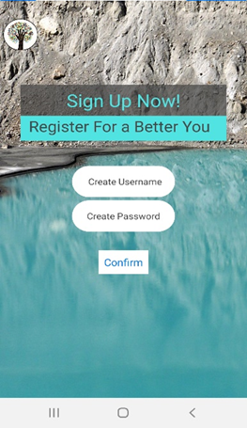

-Firstly, we came across the idea of implementing a simple interface. This makes it user friendly and uncomplicated to use the app. Our app provides the service to sign up and become a part of the FineQuo movement by simply signing up and creating a username and a password for the account. We have implemented a safety measure too to ensure a fair and trustworthy proposal- we require a minimum of 6 letters, for both username and password to safeguard your points and progress.

8

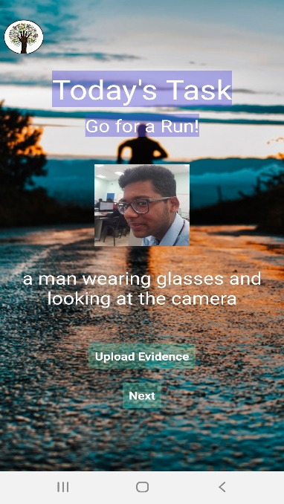Moving on…after signing up on the first slide, our app will redirect you to this slide where it exposes you to our donation scheme and tie ups. The screen will put forth a task that will encourage, slowly to follow a healthy lifestyle. Then the user would have to upload an evidence, in this case, a picture of the task completed by the user to validate whether the task is completed successfully and then the app would redirect you to the reward section and how and where you can utilize the points provided…

…This enthralling sight will first greet the user. This means that you’ve received your daily reward of 100 points (constant) and by tapping the “claim” button it will register that the points have been rewarded and won’t be able to be collect until the next 24 hours. This cements the fair and evident use of the app which also ensures us that consumers are putting forward their fair doze of usage. This ultimately justifies the small but immensely impacting steps towards the eradication of unhealthy lifestyles and a step towards healthy living. The change is inevitable.

9

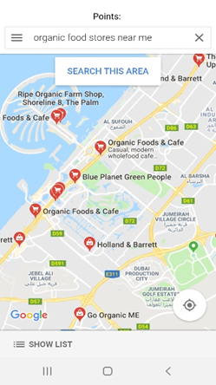

Now finally, after completing and visiting all those slides, our app will redirect the consumer to google maps where we have highlighted the organic food stores to make it an effortless experience for the consumer. In addition to this, the points earned previously can be claimed in these organic food stores for discounts and further reductions upon purchases. This won’t only encourage the consumer to purchase through these organic food stores, but it will also instil a sense of healthy living which will eventually, slowly grow and amend the consumer’s lifestyle positively.

10

Signing up will make you our registered user to eat healthy

Conclusively, FineQuo as a whole will not just remain to be an app. It would rather grow further and further to be a movement amongst all ages.

Completing the task given by the app and then uploading the evidence. Our AI will identify the stimuli and the environment and validate the task whether it’s done



Establishing and instilling a sense of following a healthy lifestyle which will not only affect us, but will affect the whole of the humanitarian society-aimed across all ages (especially people who envision a healthy life)

Our team rewards users with points, discount vouchers etc. every 24 hours. This maintains consumer loyalty, making it convenient for users to purchase healthy food without spending a penny from their savings.

Doing business with organic food stores compliments brand image and still supports healthy lifestyle as a percentage of the consumer’s money is donated to fight hunger when products are purchased through the app

11

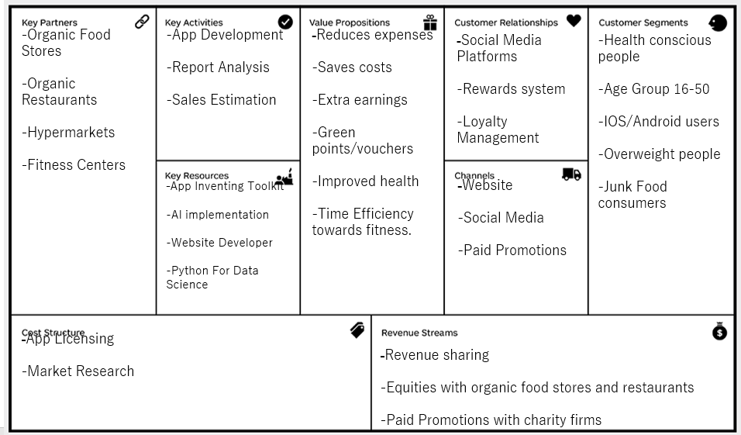

12

**Business Plan**

**Name of Business**: FineQuo

**Type of Organisation**: Public Limited Company

**Business Aim**: - To positively impact global healthcare.

**Product**: : The “FineQuo” App

**Price:** The App is free of charge

**Mainstream Stakeholders**: Registered customers, Government, Business partners

**Human Resources Plan**: Minimum percentage of 85% in Computer Science (Post graduation) and P.C.M(Physics, Chemistry, Math) for employment.

**Requirements**

- 4 years of experience in Python and JavaScript (GUI programming).

- Completion in 3-year course of Artificial Intelligence (AI).

- Preferred Fluency in **English**, Arabic and French.

**Details of business owners**

Garv Sawhney - Co-founder

Tathya Shah – Co-founder

Priyansh Mathur – Co-founder

Ishaan Meena – Co-founder

**Main Equipment Required**

Programming Software – Free to Install on Systems

Multimedia Setup - $43,000

Desktop Computers – $16,400 (16 pcs)

**Forecast Profit**: Appendix for our product: Approximately In the first year of operations the total cost forecasted to be 80,000 with a revenue of 100,000.

Predicted profit: 20000

Level of output to break even: 15,000 per year

13

**Advertisement Plan**:

-Tie-ups with organic stores, restaurants and fitness centers

-Paid Promotions on Social Media

-YouTube advertisements

-Newspaper Articles

**Target Consumers:**

- Age Group of 15-50

-IOS/Android Users

- People who envision a healthier and longer Life

**Market Research :**

-Online Surveys on Social Media Platforms

- Questionnaires In School

- Interviews With Target Consumers

- Feedback Entry on website

- Government Reports and statistics

**Competitors :**

* Foodie
* YogiApproved.com

**Interface Development:**

-Firstly, we came across the idea of implementing a simple interface. This makes it user friendly for the customer. Our app provides the service to sign up and become a part of the FineQuo movement by simply creating a username and a password for the account. We have implemented a safety measure too to ensure a fair and trustworthy proposal- we require a minimum of 6 letters, for both username and password to safeguard your points and progress.

-After signing up on the first screen, our app will redirect you to another slide where it exposes you to your fitness related task. After uploading valid evidence of task completion by clicking a post workout picture,

14

the AI in the app will detect it and redirect you to another slide

-This means that you’ve received your reward of Green points and vouchers. By tapping the “claim” button it will register that the points have been rewarded and the next reward won’t be enabled until the new task hasn’t been completed. The change is inevitable.

-Now finally, our app will redirect the consumer to google maps where we have highlighted the organic food stores and restaurants to make it an effortless experience for the consumer. In addition to this, the points earned previously can be availed to purchase organic food at minimal costs.

**Expected Forecast**: Revenue of 450,000 within the stretch of 5 years in these organic food stores for discounts and further reductions upon purchase

**Why Us?**: The world is evolving, morphed by marketing magicians into digitize emporiums for progressive public and their healthy future. Our business has an advantage over numerous other firms as the world is progressing towards a digital lifestyle even to aid the global issues.

**Target Market**: minimum 1,500,000 online registrations and app downloads within 6 months of time.

**Cash Flow**: Positive cash flow expected within 1 year

**Finance**: Loan worth $72,000 requested from bank with 3% interest (long term loan)

$34,000 investment for global advertisements and markets

15